**Solutions:**

**Problem1**. Provide the list of markets in which customer "Atliq Exclusive" operates its business in the APAC region.

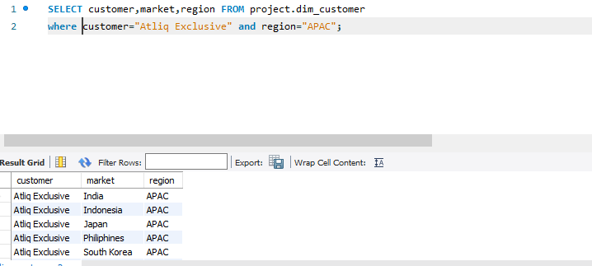

**Problem2**. What is the percentage of unique product increase in 2021 vs. 2020? The final output contains these fields, unique_products_2020 unique_products_2021 percentage_chg.

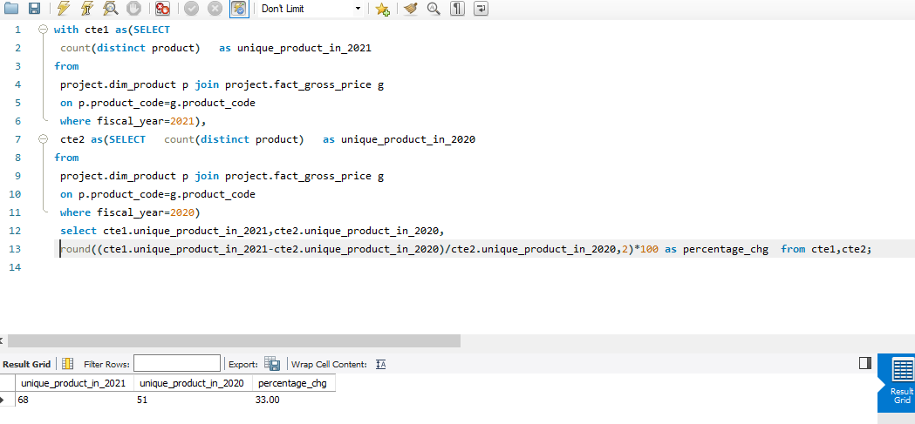

Problem3**. Provide a report with all the unique product counts for each segment and sort them in descending order of product counts. The final output contains 2 fields, segment product_count.**

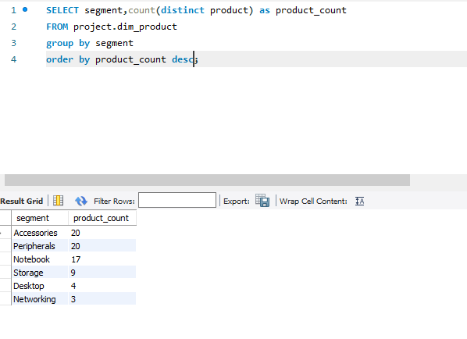

**Problem4. Follow-up: Which segment had the most increase in unique products in 2021 vs 2020? The final output contains these fields, segment product_count_2020, product_count_2021 ,difference.**

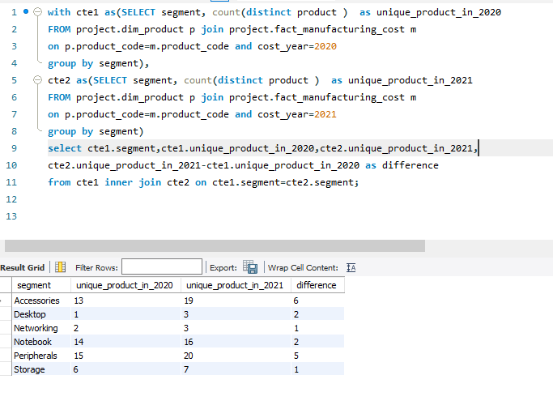

**Problem5. Get the products that have the highest and lowest manufacturing costs. The final output should contain these fields, product_code, product, manufacturing_cost.**

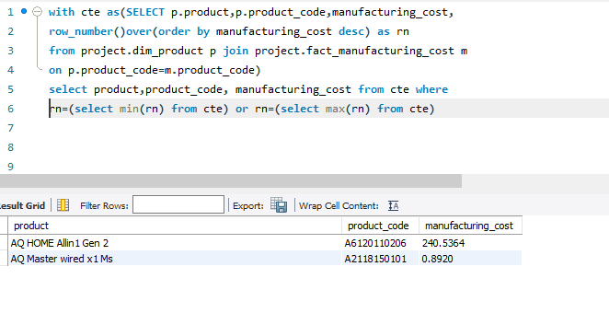

**Problem6.** **Generate a report which contains the top 5 customers who received an average high pre_invoice_discount_pct for the fiscal year 2021 and in the Indian market. The final output contains these fields, customer_code, customer, average_discount_percentage.**

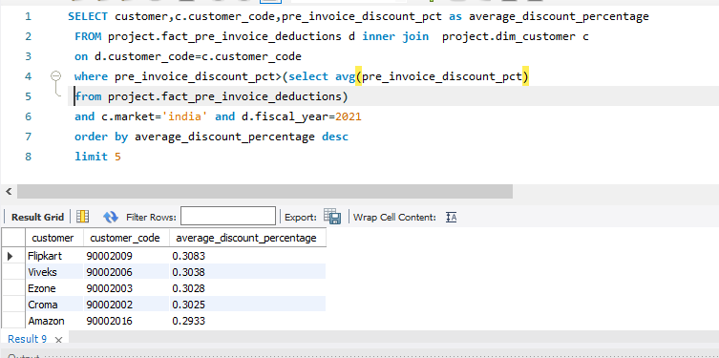

**Problem7.** **Get the complete report of the Gross sales amount for the customer “Atliq Exclusive” for each month. This analysis helps to get an idea of low and high-performing months and take strategic decisions. The final report contains these columns: Month ,Year ,Gross sales Amount.**

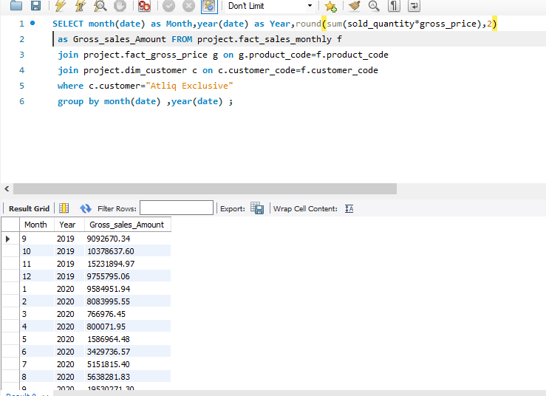

**Problem8. In which quarter of 2020, got the maximum total_sold_quantity? The final output contains these fields sorted by the total_sold_quantity: Quarter ,total_sold_quantity.**

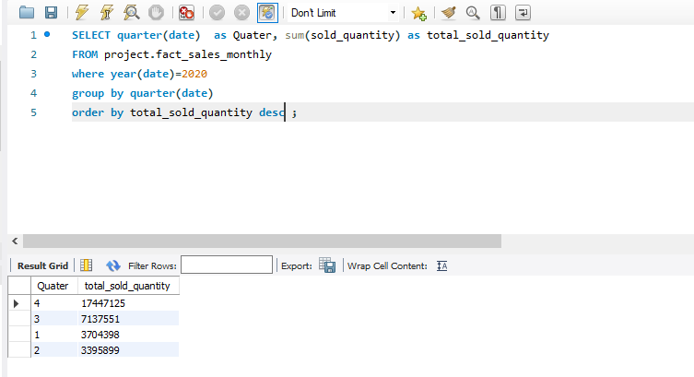

**Problem9.** **Which channel helped to bring more gross sales in the fiscal year 2021 and the percentage of contribution? The final output contains these fields, channel ,gross_sales_mln, percentage.**

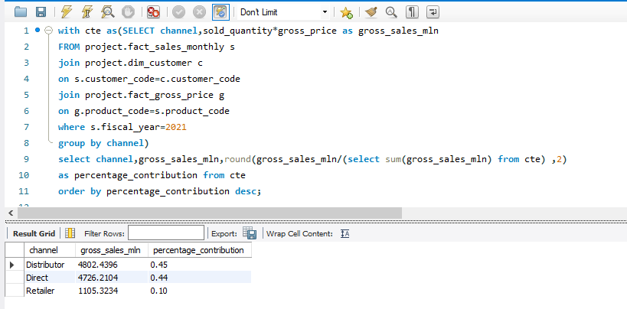

**Problem10. Get the Top 3 products in each division that have a high total_sold_quantity in the fiscal_year 2021? The final output contains these fields, division, product_code , product ,total_sold_quantity ,rank_order.**

